Representing individual teams

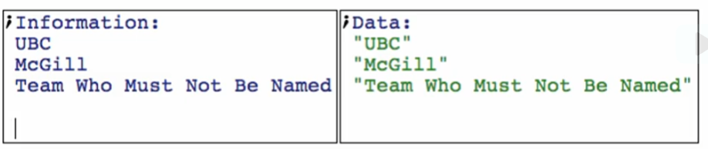

Representing list of teams (favorite teams)

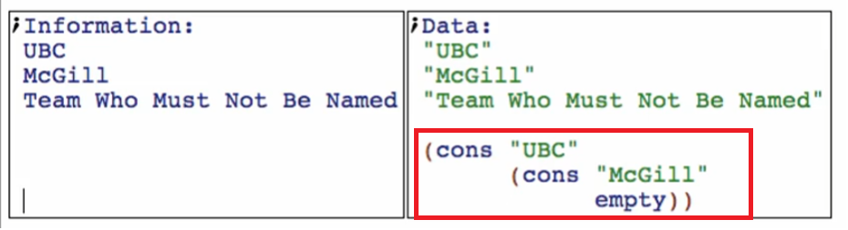

We can also use empty if you don’t like any of the teams

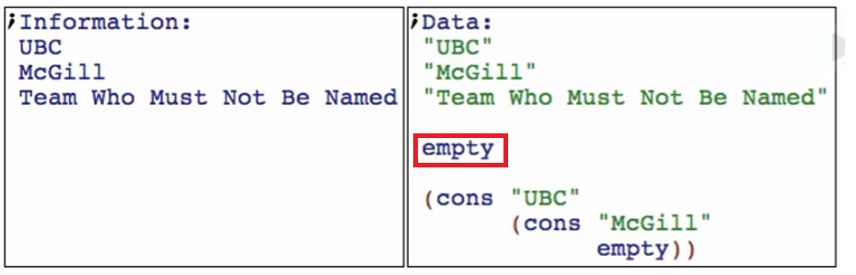

Data definition:

1. Structure – skip
2. Type comment

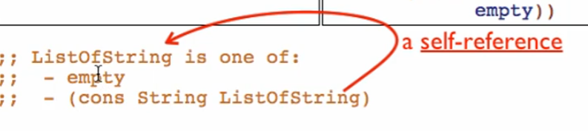

1. Interpretation



1. Examples

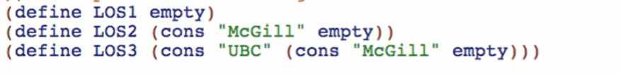

Check types

LOS1

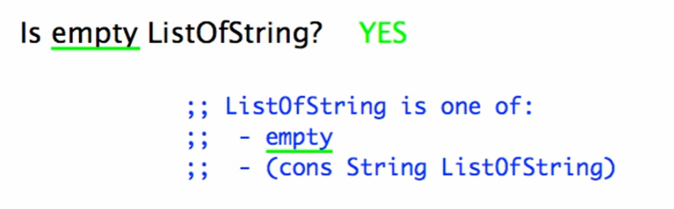

LOS2

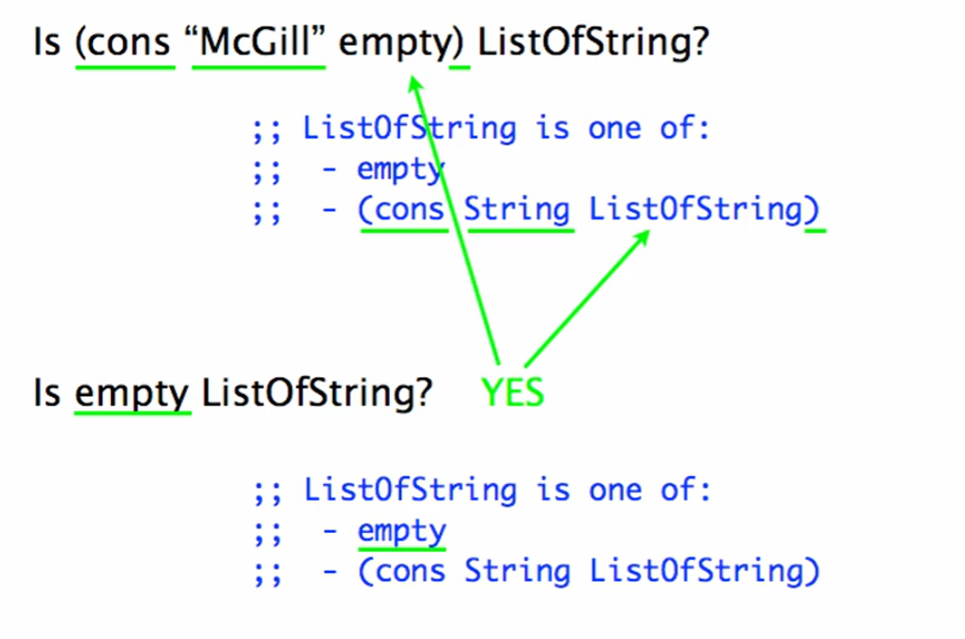

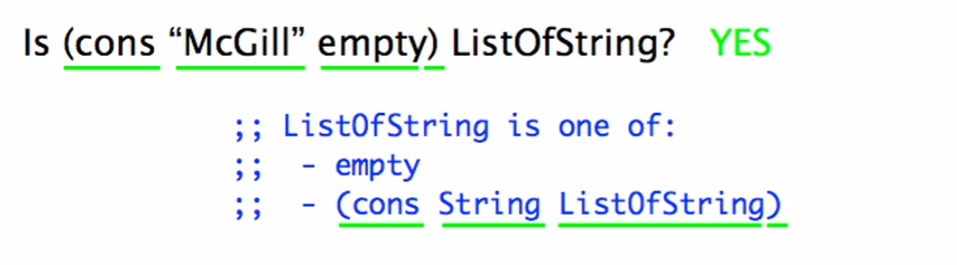

LOS3 – follow LOS2

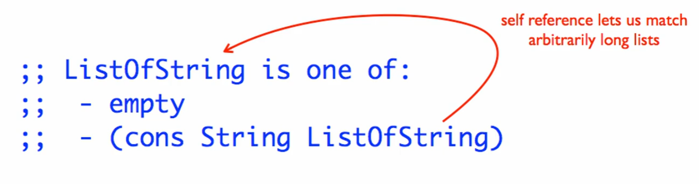

1. Template

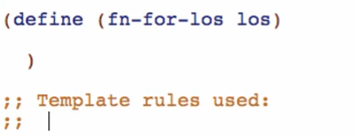

for one of:

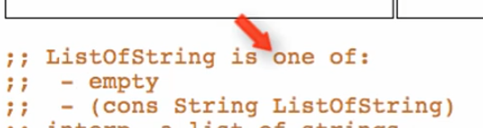

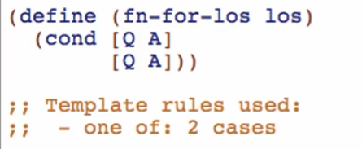

for empty:

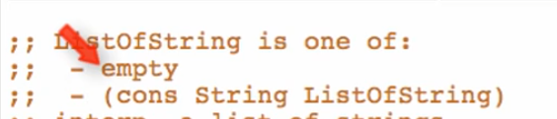

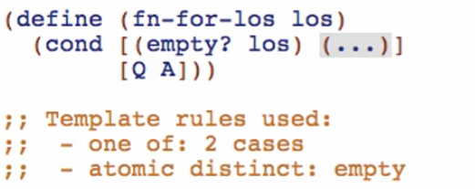

for (cons String ListOfString): -> compound data

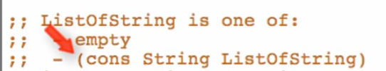

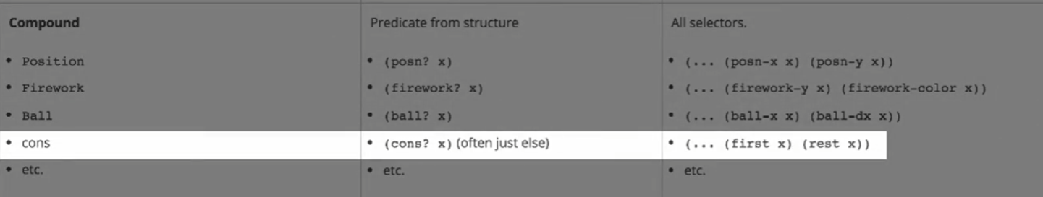

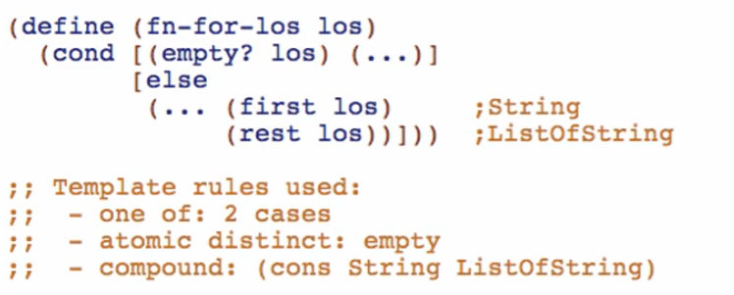

Making a lucky guess: the function for rest los

